

**Faculty of Computer and Information(FCI)**

**Department of Information Technology(IT)**

**Health Care by Fitness**

**Supervisor**

**Dr/ Arabi keshk**

**2019**

**Team Work**

**Mostafa abd-elhakem sedky wahb**

**Ahmed Ibrahiem amin elbasuiny**

**Mohamed fakry elshenawy**

**Mostafa adel abd-elfatah**

**Mohamed mohamed abd ellah gamal eldin**

**Mohamed abd-elmordy elmorshdy**

Abstract

**Context:** In this book we will talk about caring for the body and its health care through physical fitness. Also, we will make it clear that leisure time can be exploited well and regularly to upgrade the physical fitness of the user. This will be done by using the Android application. And how you can benefit from them.

**Objectives**: Utilizing the optimal time to upgrade the fitness level of the user, the application of the android applications appropriately as a simple application for health care by using physical fitness in a simple way.

**Methods:** We have done a review of the physical exercises that can be done at home, and we did a research to know the number of calories that the exercise burn after the user to do the exercise, and ultimately Jiej exercise for these exercises on the Android application to be easy for the user to see and use.

**Contents**

**1 1- Introduction:**

**1 1.1 What is Android?**

**2 1.2 Where does Android come from?**

**2 1.3 What is the difference between Android and iPhone?**

**3 1.4 Why does Android look different on each phone?**

**4 1.5 What are the advantages of Android?**

**4 1.6 What’s with the candy names?**

**5 1.7 What’s the best thing about Android?**

**5 1.8 What’s the worst thing about Android?**

**6 1.9 What is Google Play / Play Store?**

**7 1.10 Here are some Android terms you should know**

**11 2-Software requirement:**

**11 2.1 Description:**

**11 2.2 Function requirement:**

**12 2.3 Non-Function requirement:**

**2.4 Service provider: 2.5 Gaps in this field: 2.6 The agile method:**

**15 3- Design and implementation:**

**3.1 Material Design for Android: 15**

**3.2 Material theme and widgets: 15-23**

**4- System Analysis: 24**

**24-26 4.1 UML Class Diagram:**

**27 4.2 Activity Diagram:**

**28 4-3 State diagram:**

**29 4-4 Sequence diagram:**

**30 5- Conclusion:**

**31 5.1 Objective satisfaction:**

**32 5.2 Future work:**

**33 6- Health care apps:**

**34 5.1 Health care:**

**38 5.1 Benefits of health care Apps:**

**Chapter**

**1**

**Introduction**



1- Introduction:

**1.1 What is Android?**

Android is software for mobile phones, tablets and a growing range of devices encompassing everything from wearable computing to in-car entertainment. It launched in 2003 and is the world’s most popular mobile operating system (OS).

Android is an open source project (led by Google but it doesn't belong to them) called AOSP (Android Open Source Project). Google uses this project as a base to create its version of Android, which is then used by the other manufacturers.

As an OS, Android's job is to act as a translator between you and your gadget. When you take a photo, Android provides the button you tap and tells the phone what to do when you tap it. When you make or receive a call, Android tells your phone how to do that. When you play a game, Android tells the game what movements you’re making and what buttons you’re pressing. It’s like Windows, but for mobile devices.

The Android software itself is developed in conjunction with Google, who releases major updates to the platform every year. Manufacturers which run Android on their phones include Samsung, Huawei, Sony, Lenovo, HTC, LG and many others; it's currently operational on more than one billion devices.

**1**

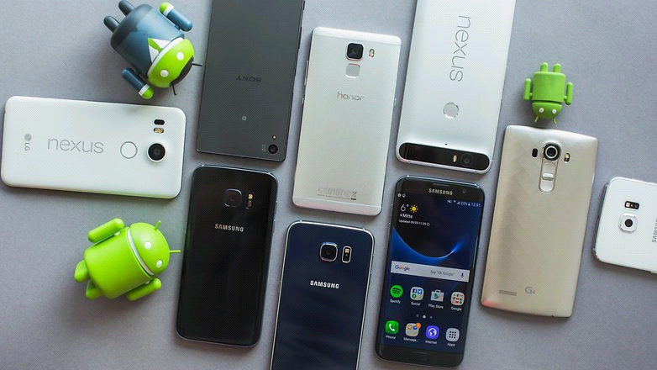

**1.2 Where does Android come from?**

It comes from Google, who actually acquired Android in 2005 (no, Google didn't invent it). The search giant performs regular updates along with an annual major update.

The operating system is based on the Linux kernel – if you have friends who work in IT, you may have heard of it. This is the GNU / Linux operating system based structure, which is a unix type system (portable operating system, multitasking and multi-user). The Linux kernel is one of the most prominent examples of free software.

**1.3 What is the difference between Android and iPhone?**

It’s not so much a difference between Android and iPhone but Android and *iOS*. You see, iOS is the software which runs on iPhones and the differences between this and Android are simultaneously big and small.

Smartphones with Android or iOS installed are capable of doing most of the same things: they can both run apps, connect to Wi-Fi, take photos, send messages etc. But there are many differences in how they look and feel, and the possibilities of both.

**2**

* You can read more about how the latest versions of iOS and Android compare here.

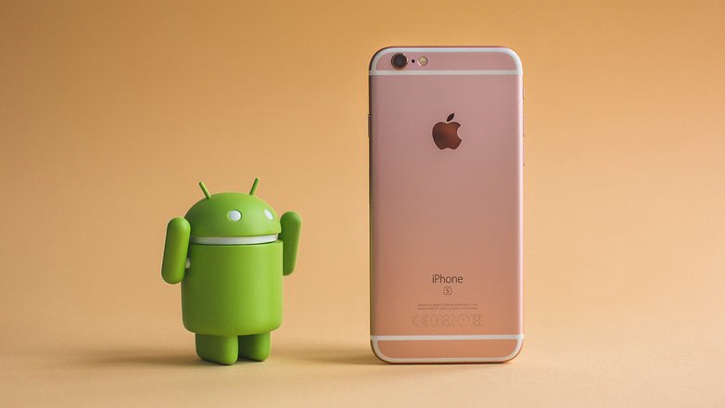

**1.4 Why does Android look different on each phone?**

Android doesn't look different on *every* device, but it does have a number of different versions. Android is open-source, which means that manufacturers are free to customize the software and make it their own.

The 'purest' version of Android is often referred to as 'stock Android' and it's often preferred by the Android community: it's the original software as Google intended.

Other user interfaces (UI) include Samsung's TouchWiz, Sony's Xperia, and Huawei's Emotion. See what they all look like in our [Android UI comparison](https://www.androidpit.com/android-ui-comparison).

**3**

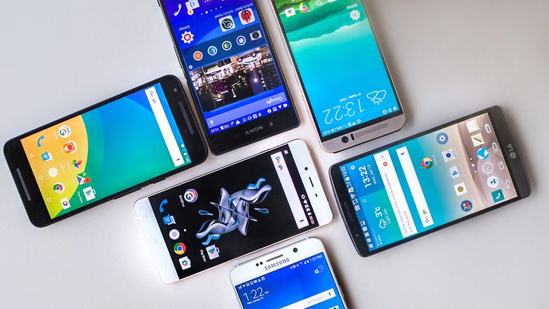

**1.5 What are the advantages of Android?**

Choice. For example, if you want iOS, you have a choice of iPhone, iPhone or iPhone. If you go for Android there are stacks of great devices to choose from, from cheap and cheerful handsets to really impressive flagships. Those flagships are often cheaper than the equivalent Apple devices, too.

Android’s choice isn’t just about hardware. It’s about everything else too. Android is incredibly easy to customize, both in terms of how it looks and how it works, and the various app stores aren’t as tightly controlled as its rivals’ stores, like Apple.

**1.6 What’s with the candy names?**

Each new version of Android gets a code name based on consecutive letters of the alphabet. The most recent version is known as [Marshmallow](https://www.androidpit.com/android-m-release-date-news-features-name) because it is the Android M release.

Previous versions have included 50Lollipop, KitKat, Jelly Bean and Gingerbread.

4

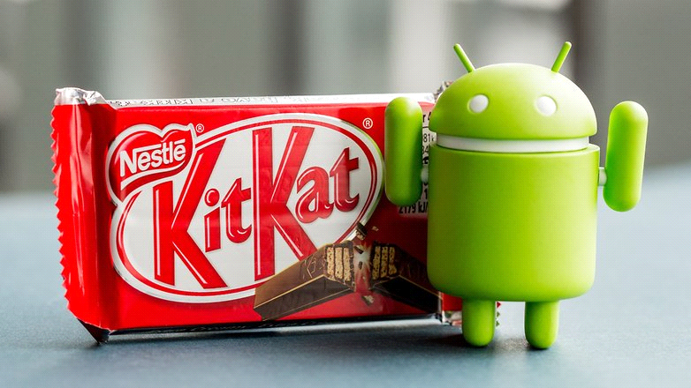

**1.7 What’s the best thing about Android?**

Options, many options. With Android you have hundreds of gadgets at your disposal, the cheapest, the most expensive and innovative market. Android is also incredibly customizable, both in their roles, as in his appearance. You can really make a unique mobile experience for yourself with this OS.

**1.8 What’s the worst thing about Android?**

Getting updates. In many cases manufacturers don’t seem to care about providing software updates for devices they’ve already sold you. Even when they do provide updates they take their sweet time about it. That’s why some [consider rooting](https://www.androidpit.com/how-to-root): you can download the updates yourself and apply them instead of waiting for the manufacturer to get around to it.

**5**

**1.9 What is Google Play / Play Store?**

The Google Play Store is a digital marketplace where Android users can purchase apps, games, books, movies, music and more. And it's a big advantage to owning an Android device.

The purchased content is connected to your Google account – something you must have in order to make these purchases – and is available on any device where you log in with your Google account.

* [Google Play tips and tricks](https://www.androidpit.com/tips-and-tricks-for-google-play) every Android user needs to know

[Google Play not working?](https://www.androidpit.com/google-play-not-working)

Here's what you can do

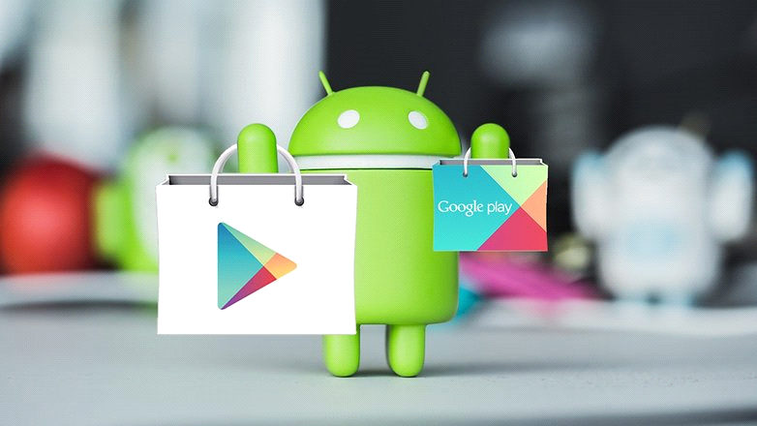

**6**

**1.10 Here are some Android terms you should know**

Here is a glossary of terms you can refer back to as you continue in our series. Have a read through them right now to get a brief overview. Click on one in the table to jump to the term.

|  |  |  |  |
| --- | --- | --- | --- |
| [ADB](https://www.androidpit.com/what-is-android) | [Download Mode](https://www.androidpit.com/what-is-android) | [MicroSD](https://www.androidpit.com/what-is-android) | [ROM](https://www.androidpit.com/what-is-android) |
| [APK](https://www.androidpit.com/what-is-android) | [Factory Reset](https://www.androidpit.com/what-is-android) | [ODIN](https://www.androidpit.com/what-is-android) | [Root](https://www.androidpit.com/what-is-android) |
| [Application](https://www.androidpit.com/what-is-android) | [Firmware](https://www.androidpit.com/what-is-android) | [Open Source](https://www.androidpit.com/what-is-android) | [Soft Reset](https://www.androidpit.com/what-is-android) |
| [Backup](https://www.androidpit.com/what-is-android) | [Flash](https://www.androidpit.com/what-is-android) | [Operating System](https://www.androidpit.com/what-is-android) | [Unlock](https://www.androidpit.com/what-is-android) |
| [Bluetooth](https://www.androidpit.com/what-is-android) | [Kernel](https://www.androidpit.com/what-is-android) | [OTA](https://www.androidpit.com/what-is-android) | [Widget](https://www.androidpit.com/what-is-android) |
| [Bootloader](https://www.androidpit.com/what-is-android) | [KIES](https://www.androidpit.com/what-is-android) | [QR](https://www.androidpit.com/what-is-android) | [Wipe](https://www.androidpit.com/what-is-android) |
| [Brick](https://www.androidpit.com/what-is-android) | [Launcher](https://www.androidpit.com/what-is-android) | [Recovery Mode](https://www.androidpit.com/what-is-android) | [Window](https://www.androidpit.com/what-is-android) |

*ADB*: Stands for Android Debug Bridge, a tool that is used primarily by developers to send commands from a computer to Android. It works as a client-server and gives you tools for the devices for debugging.

*APK*: Android application package file used to distribute and install apps. This file contains the app code, resources, assets and manifest file.

*Application*: An application or app is something you use to perform functions on the phone. These range from simple to incredibly complex.

*Backup*: To keep your data in a safe place in case of a problem where you lose your important information.

*Bluetooth*: Data transmission system between devices via radio waves without using wires or other connectors.

*Bootloading*: Procedure that allows you to access recovery mode

*Brick*: When the device does not start and becomes unusable due to a configuration error after making a change.

**7**

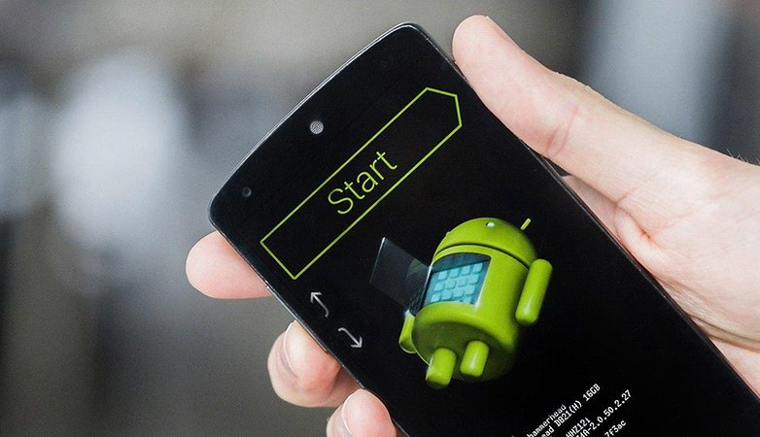

Download Mode: Used to install or replace the firmware of your device or a new ROM.

Factory Reset: Restoring the device to the original settings.

*Firmware*: The contents of the device's ROM. To find out the firmware version of your device go the *Settings*, tap *About Phone* and hit *Software Information*.

*Flash*: Changing the ROM of a device.

*Kernel*: The core of the operating system. It's responsible for uniting the software functions and the hardware.

*KIES*: Samsung application that allows you to update and synchronize the data from your smartphone or tablet.

*Launcher*: Responsible for customizing the device by modifying the user interface.

*MicroSD*: Removable memory card format. Smaller than MiniSD, it's used for mobile devices.

**8**

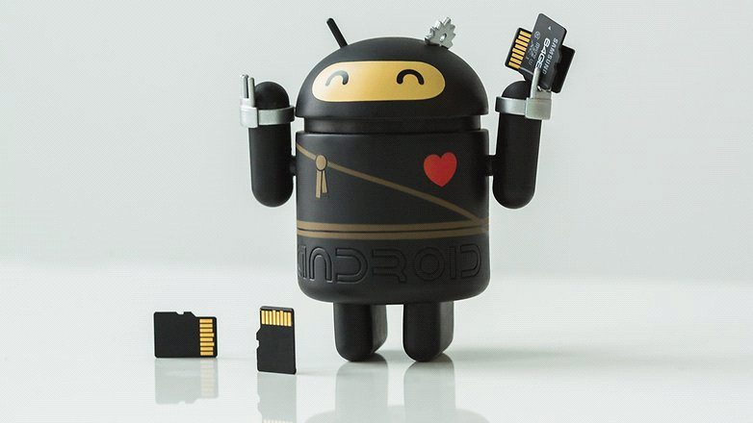

*ODIN*: Program to flash your device.

*Open Source*: Software that is made available to be distributed and modified.

*Operating System*: Software that controls a device's basic functions like scheduling tasks and executing applications.

*OTA*: Stands for 'Over The Air' and refers to updates that are made from your device without using cords or other connectors.

*QR*: Abbreviation for 'Quick Response' and is a black and white code that can be scanned with your device to open a link or application.

*Recovery Mode*: A method of starting your Android in order to install a ROM, wipe your device or format it.

*ROM*: Stands for 'Read Only Memory' and is a type of storage for Android devices. It has the programming for starting a device and performs most of the tasks.

*Root*: The act of unlocking the Android OS to gain complete control over the device through which you can access hidden files, change the ROM or install certain special apps.

**9**

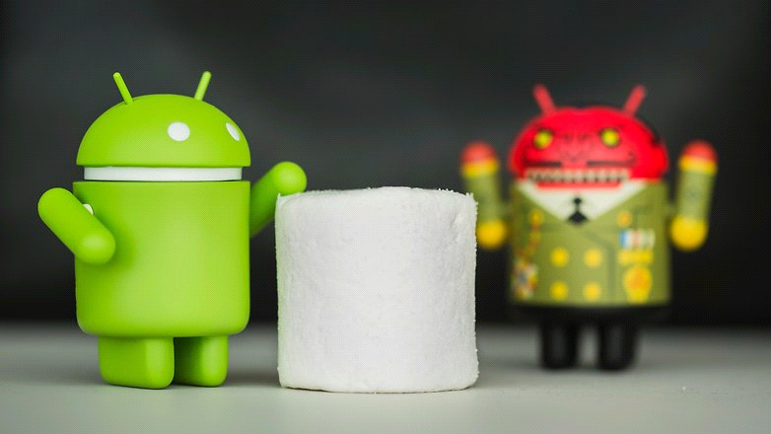

*Soft Reset*: The act of rebooting your phone, intentionally or not. It has the same effect as when you remove your battery.

*Unlock*: You must perform this before you can use a SIM card from any carrier.

*Widget*: 'Icon' or part of an application that you can put on your home screen to quickly view information or to access the app faster and easier.

*Wipe*: Formatting the device. Deletes the external data from the device.

*Windows*: In Android apps, they are objects that specify the look and feel of the content.

**10**

**Chapter**

**2**

**Software Requirment**



2-Software requirement:

**2.1 Description:**

The application helps people take advantages of their time to improve physical fitness through some regular exercise.

This group of exercises arranged according to the age of the person and leisure time, the program after exercises count calories and time management for the next exercises.

Keeping track of the relationships between functional and non-functional requirements is difficult because non-functional requirements are sometimes system level requirements rather than requirements which are specific to a single function or group of functions.

One approach that can be used is to explicitly identify system-level nonfunctional requirements that are associated with a functional requirement and list them separately. All system requirements that are relevant for each functional requirement should be listed..

**2.2 Function requirement:**

We must know the appropriate exercises for each age, as you should also know the right way to perform these exercises, also you should know the number of calories that are burned after doing these exercises.

The right time to perform sports exercises is very important, as the right time is determined for the user to perform these athletic exercises.

1) User time.

2) Number of calories per exercises.

3) Way to do these dates.

**11**

**2.3 Non-Function requirement:**

Non-functional requirements are often called "[quality attributes](https://en.wikipedia.org/wiki/List_of_system_quality_attributes)" of a system. Other terms for non-functional requirements are "qualities", "quality goals", "quality of service requirements", "constraints" and "non-behavioral requirements".

[Avalability](https://en.wikipedia.org/wiki/Accessibility)1)

[Adaptability](https://en.wikipedia.org/wiki/Adaptability)2)

3) Data integrity

4) Reliability

**2.4 Service provider:**

Many companies rely on Android for their applications such as Facebook, Twitter, site services, messaging and chat, all of which make it easy to communicate and communicate with peopleThese companies use analysis tools such as Javascript, JavaScript, and secure profiles.

**2.5 Gaps in this field:**

The problem facing Android applications is that it does not work on operating systems such as IOS and Windows.



**2.6 The agile method:**

In this application the agile method is used, **Agile development model** is also a type of [**Incremental model**](http://istqbexamcertification.com/what-is-incremental-model-advantages-disadvantages-and-when-to-use-it/).

Software is developed in incremental, rapid cycles. This results in small incremental releases with each release building on previous functionality. Each release is thoroughly [**tested**](http://istqbexamcertification.com/why-is-testing-necessary/) to ensure is maintained.

[**software quality**](http://istqbexamcertification.com/what-is-software-quality/) It is used for time critical applications.  Extreme Programming (XP) is currently one of the most well known agile [**development life cycle model**](http://istqbexamcertification.com/what-are-the-software-development-models/).

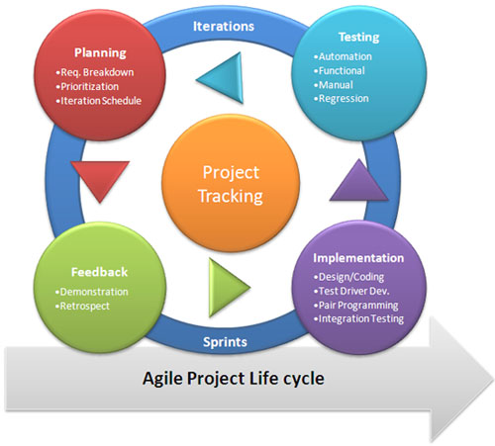

**13**

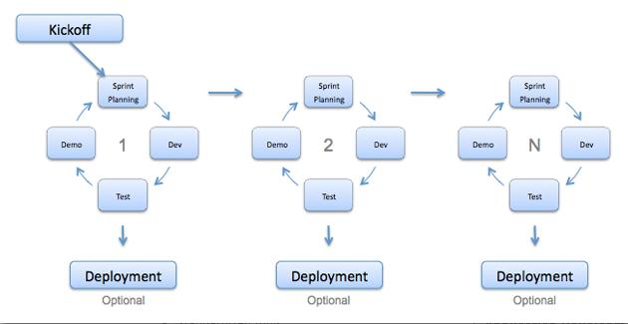

**Advantages of Agile model:**

* Customer satisfaction by rapid, continuous delivery of useful software.
* People and interactions are emphasized rather than process and tools. Customers, developers and testers constantly interact with each other.
* Working software is delivered frequently (weeks rather than months).
* Face-to-face conversation is the best form of communication.
* Close, daily cooperation between business people and developers.
* Continuous attention to technical excellence and good design.
* Regular adaptation to changing circumstances.
* Even late changes in requirements are welcomed

**Disadvantages of Agile model:**

* In case of some software deliverables, especially the large ones, it is difficult to assess the effort required at the beginning of the software development life cycle.
* There is lack of emphasis on necessary designing and documentation.
* The project can easily get taken off track if the customer representative is not clear what final outcome that they want.
* Only senior programmers are capable of taking the kind of decisions required during the development process. Hence it has no place for newbie programmers, unless combined with experienced resources.

**14**

**Chapter**

**3**

**Design and Implementation**



**3- Design and implementation:**

**3.1 Material Design for Android:**

Material design is a comprehensive guide for visual, motion, and interaction design across platforms and devices. To use material design in your Android apps, follow the guidelines defined in the [material design specification](https://material.io/guidelines/) and use the new components and styles available in the [material design support library](https://developer.android.com/topic/libraries/support-library/features.html#material-design). This page provides an overview of the patterns and APIs you should use.

Android provides the following features to help you build material design apps:

* A material design app theme to style all your UI widgets
* Widgets for complex views such as lists and cards
* New APIs for custom shadows and animations

**3.2 Material theme and widgets:**

To take advantage of the material features such as styling for standard UI widgets, and to streamline your app's style definition, apply a material-based theme to your app.

**15**

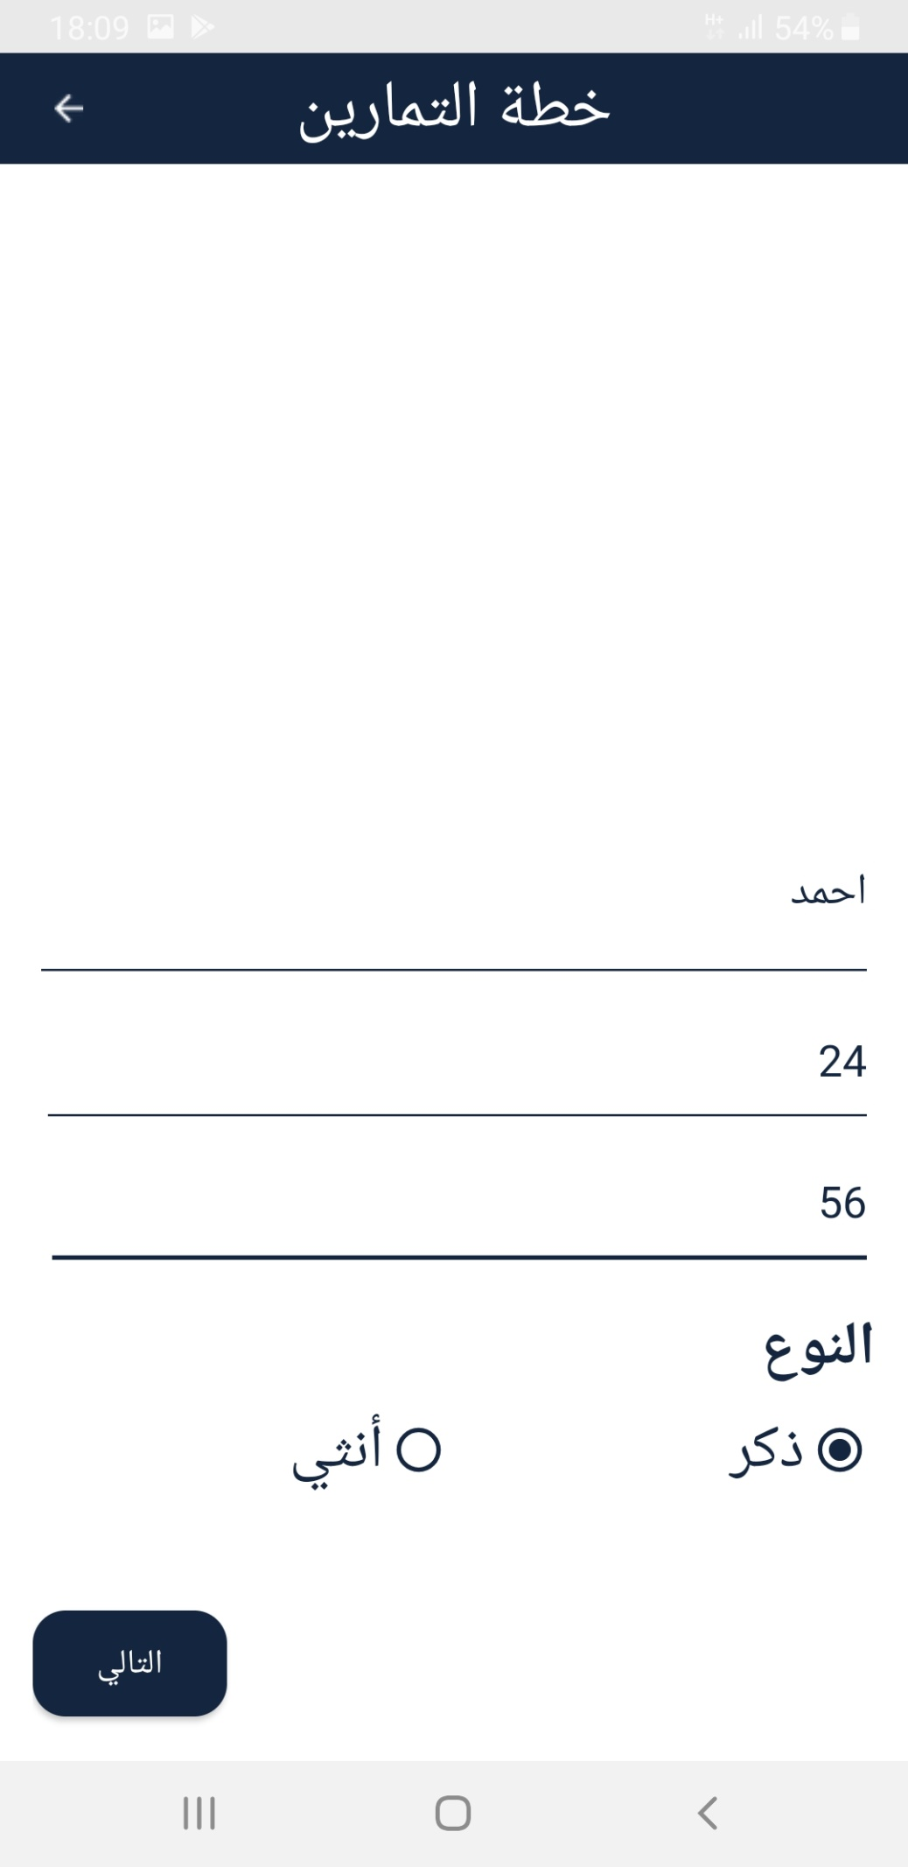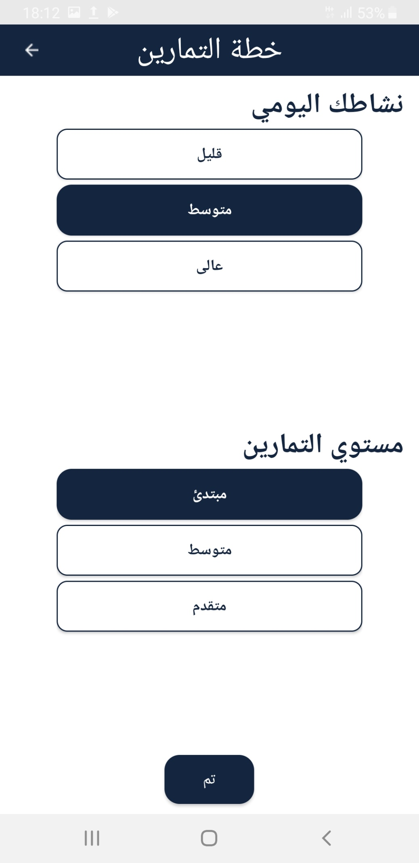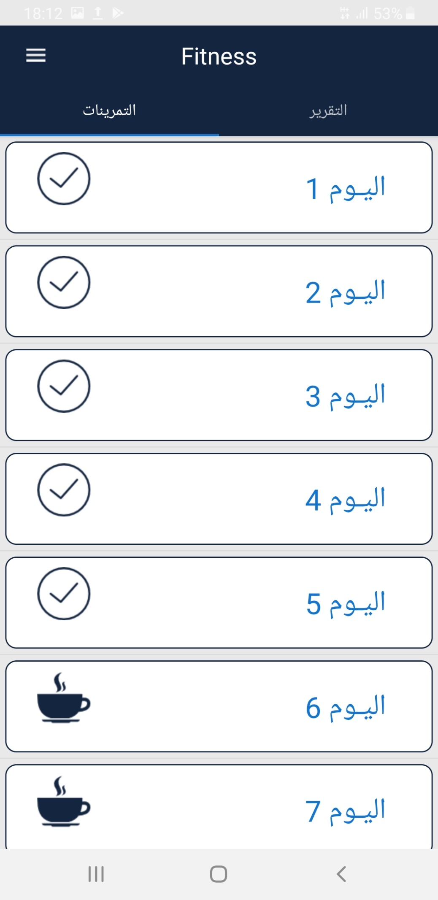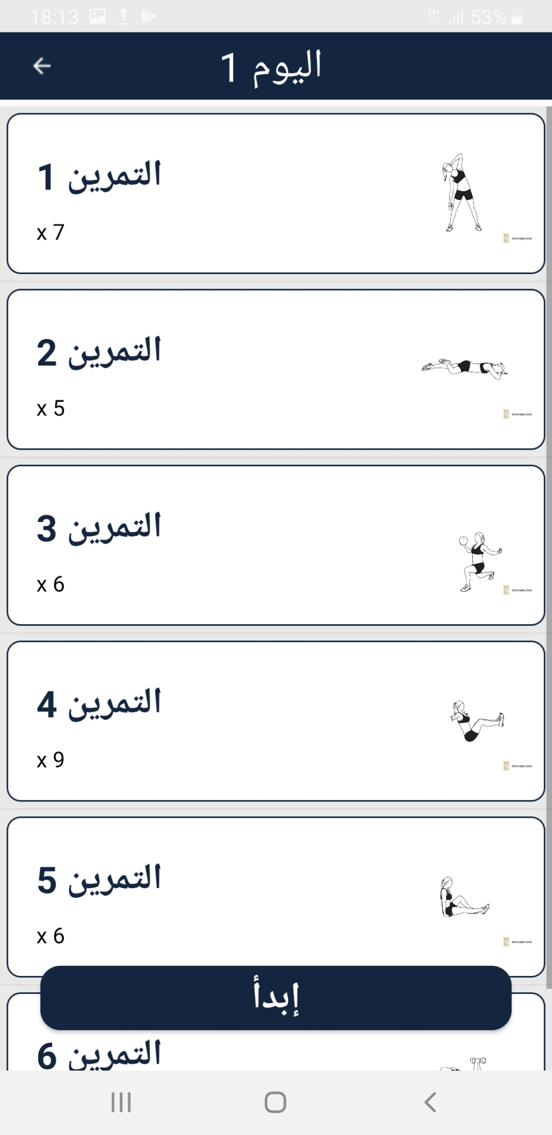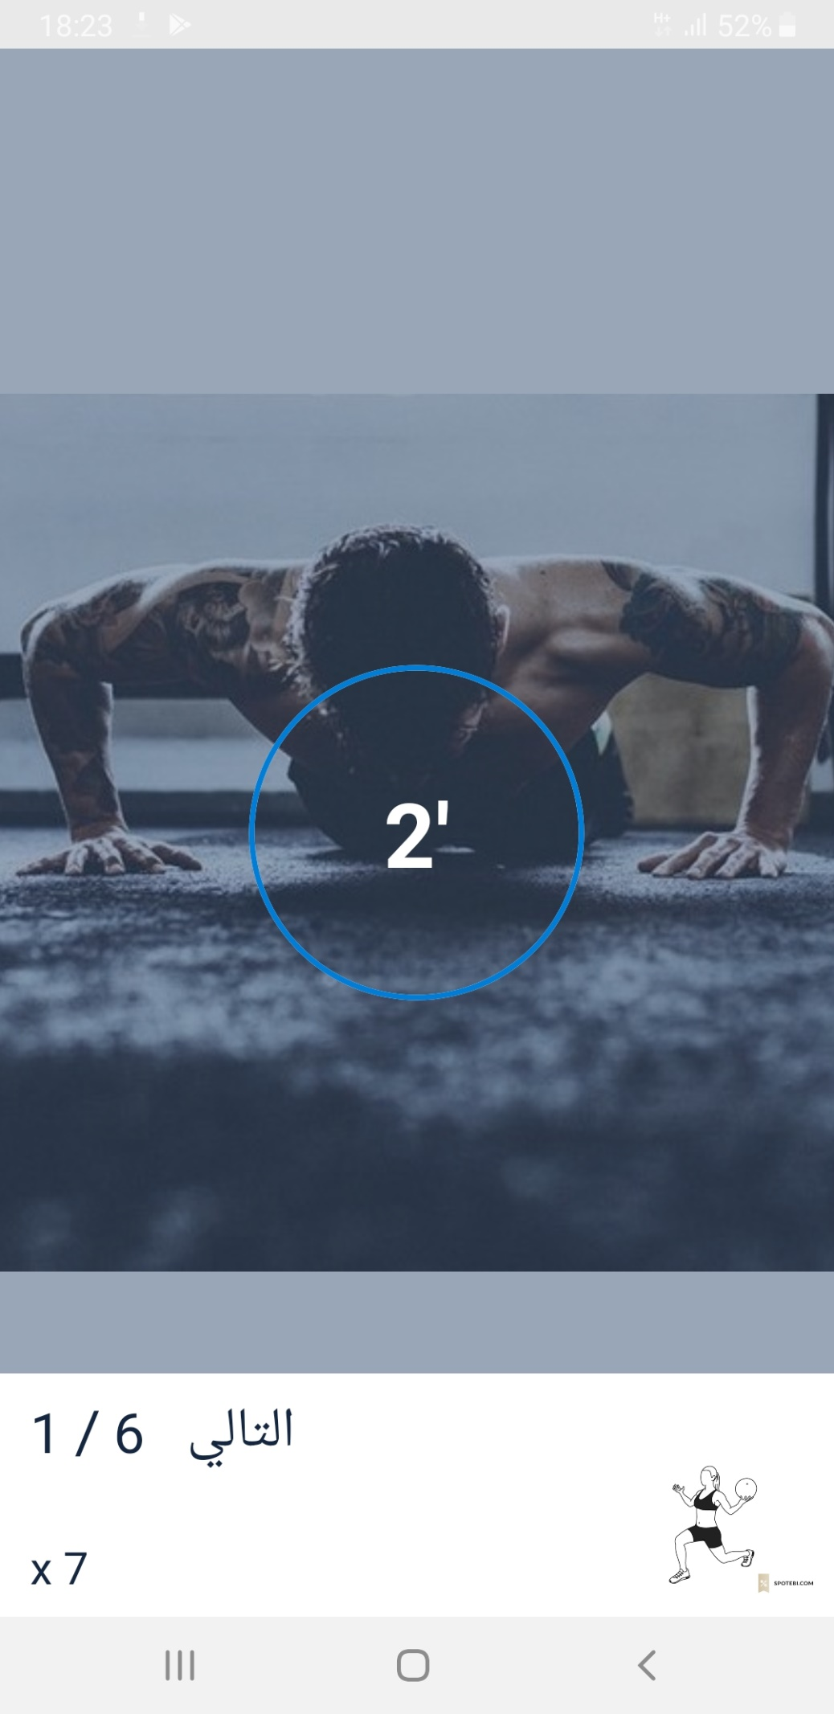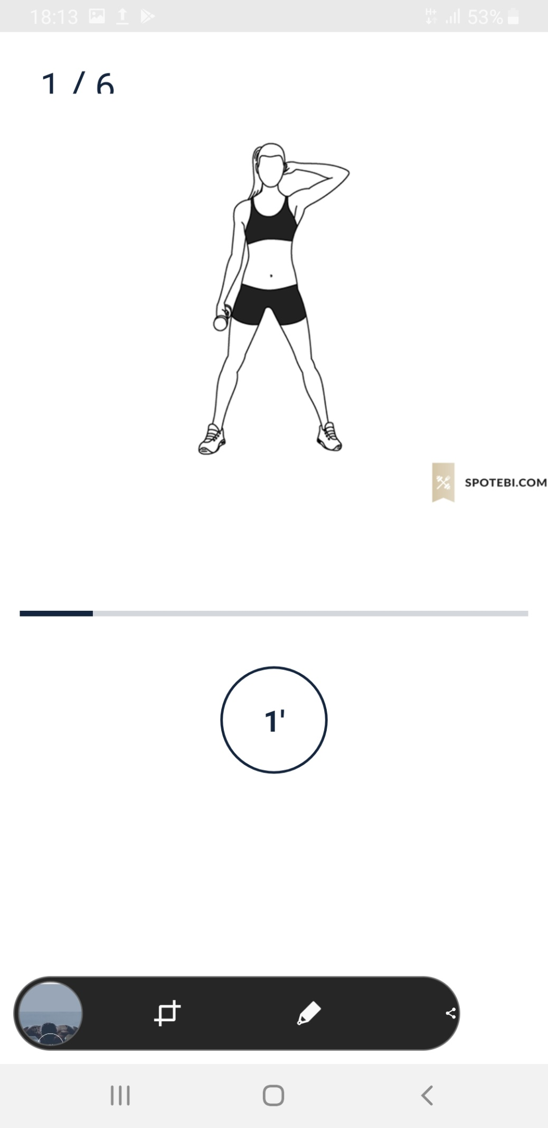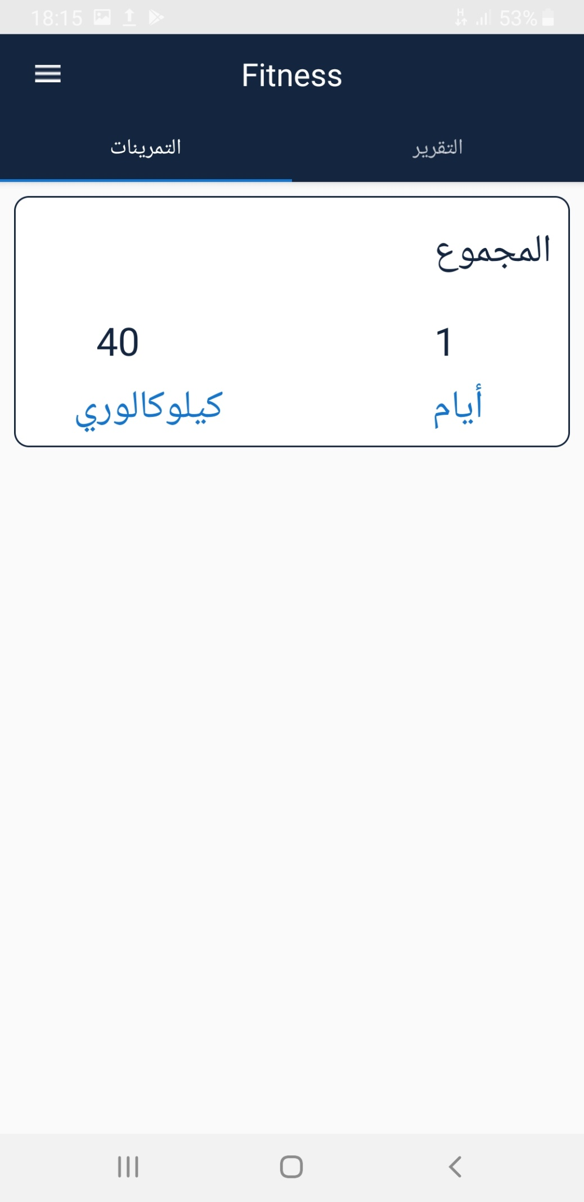

**After the user enters his or her data, including name, age, and gender, the user will then log on to the second page if this is the first time the user has used the application, and determines whether the time is busy or not, and also his level of physical fitness.After the introduction of these data show him a set of exercises to be followed, and taking into account the time and difficulty and ease of each exercise in relation to the age and type of the person.**

**The user will exercise these exercises day after day until the level of physical fitness, divided by a total of exercises to four weeks, which are used every week by physical exercises in the first five days and take the sixth and seventh day rest of the physical exercises to rest his muscles and body.**

**After the user completes the performance of the exercises for the whole month he enters a higher level automatically, and if the user interrupted the exercise because of the traffic jam time can enter again and record the data and in this case the old data is deleted because of its importance.**

**The user can also set the alarm clock to organize the time of the exercises according to the appropriate time, and can review his daily report and vision notification.**

**23**

**Chapter**

**4**

**System Analysis**



**4- System Analysis:**

**4.1 UML Class Diagram:**

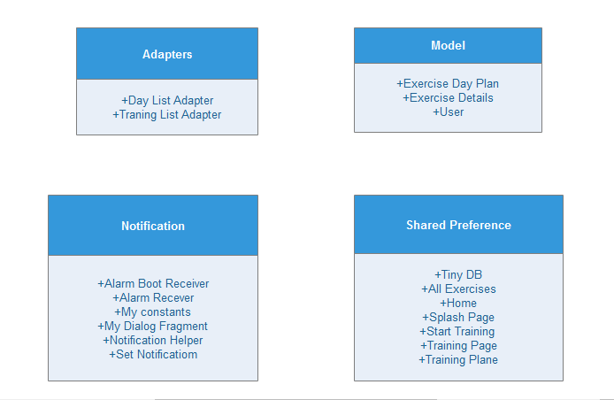

**This is not classes, this is description or container to the classes and we will describe it later.**

**Some Classes are build in android, there attributes oe methods are build in the library of android.**

**24**

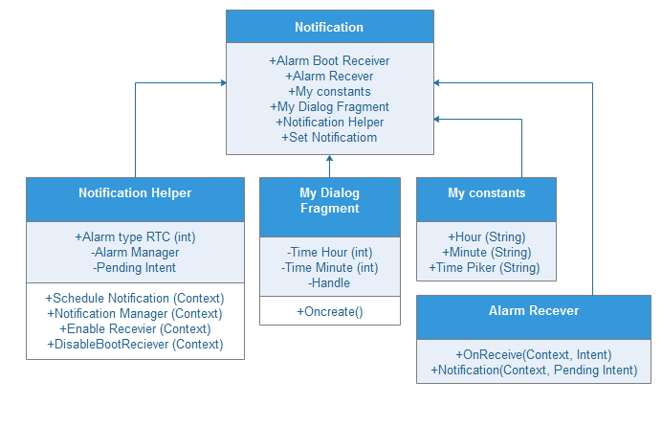

**The Notification class is container for real classes such as Notification Helper, My Dialog Fragment, Alarm Recever and My Constants.**

**Some classes are build in android like Alarm Boot Recevier, the code of this class are intent or extend from class build in android.**

**25**

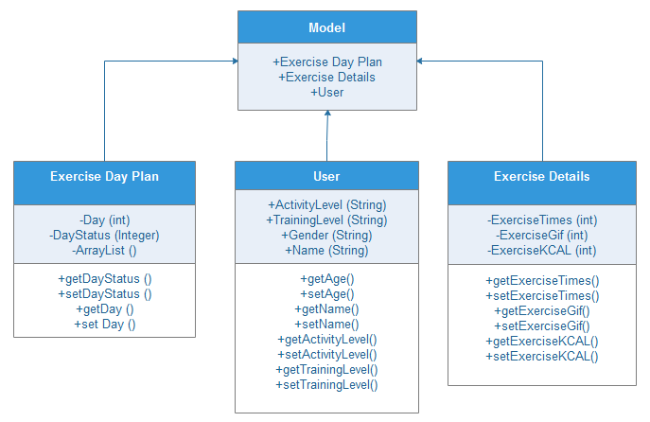

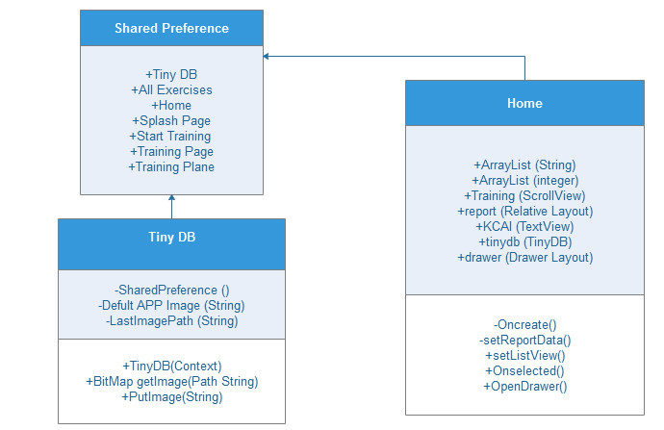

**26**

**4.2 Activity Diagram:**

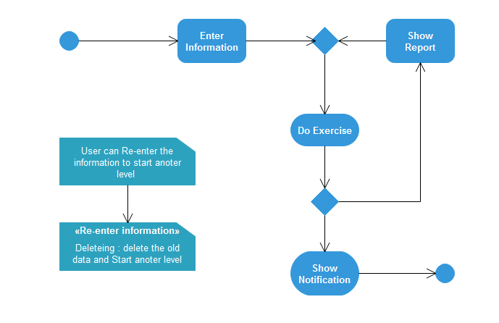

**In this diagram, it explains the activities that the user performs after running the application until it is finished. It also shows that the user can re-enter his personal data more than once.**

**27**

**4-3 State diagram:**

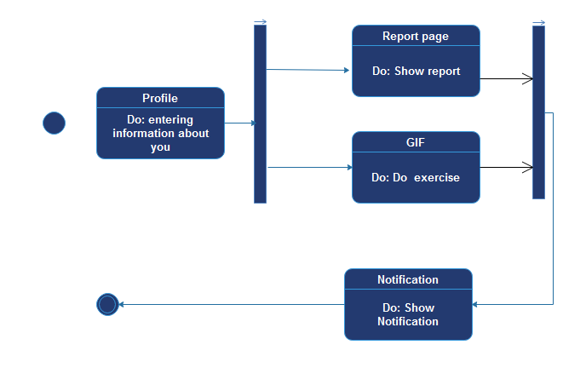

**In this diagram he explains the cases that the user uses after running the application until it is finished, and also shows that the user can re-enter his personal data more than once.**

**28**

**4-4 Sequence diagram:**

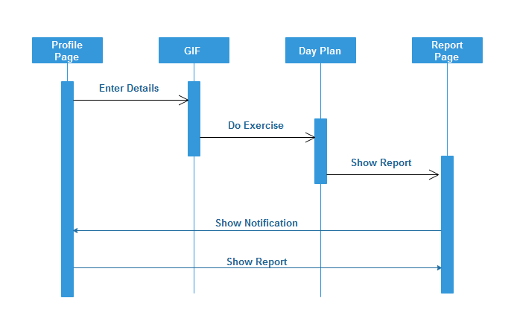

**A sequence diagram shows object interactions arranged in time sequence. It depicts the objects and classes involved in the scenario and the sequence of messages exchanged between the objects needed to carry out the functionality of the scenario. Sequence diagrams are typically associated with use case realizations in the Logical View of the system under development.**

**29**

**Chapter**

**5**

**Conclusion**



**5- Conclusion:**

This final chapter presents a review of the relevant information from this work and an exposition of future work and research.

Section 5.1 gives an overall description of the work done, from the performance improvements of the fitness application, to best level introduced by the application.

Finally section 5.2 exposes future work that could follow tha development of an Android-based implementation of the health care by fitness.

**5.1 Objective satisfaction:**

The main reason for this work is to pay attention to health care by upgrading the physical fitness of people, assisted by android applications.

According to the World Health Organization, the lack of physical fitness on a daily basis leads to Overweight.

The World Health Organization (WHO) is overweight and pandemic. Millions will suffer from serious, weight-related illnesses that are a complex condition with social and psychological dimensions among all ages. It affects 300 million people in the world, including 20 million under the age of 18. There are 120 million people with weight problems.

Why we used an android?

IPhone will give you a simple but limited interface unlike what is in the world of Android is an open world It will provide you boxes of information and a better system of light alerts of what is in the iOS also gave companies the freedom to modify the interface completely and here we see more options like HTC and LG, Samsung and many other companies.

**30**

In the Android world you will find many, many options to choose the phone you want, such as choosing an Android phone with a keyboard or choosing a curved screen phone or choosing a mobile phone that will withstand the most difficult conditions such as water and dust and forget the specifications and screen sizes of up to 8 inches. What is in the world of iPhone and is limited to two dimensions at the moment.

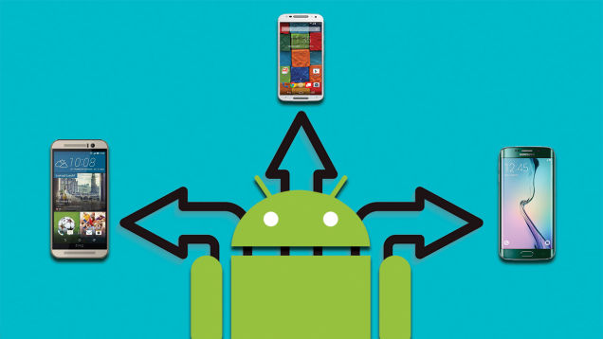

If you want to copy a file in your iPhone, try iTunes and create an account. From here, you can transfer pictures, media and more to your iPhone. In Android, you can connect your phone to your computer and switch your phone to an external hard drive. Mobile with ease.

Apple is very strict on this, but in the Android world, there are options to install applications from any store and not only limited to Google Play Store, such as the Amazon store for applications, and the possibility to download the application from any browser and transfer it on your mobile without having to go back to the store.

31

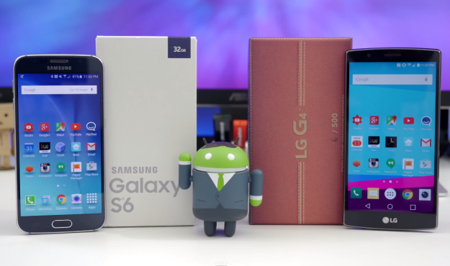

Of course, the iPhone 6 is the only one from Apple that offers a 1080 resolution in 1920. This clarity appeared on the Android phone two years ago, but now the Android comes with different technologies such as Super Amolide, SLCD, Quantum Dot, and a clarity of up to 1440 in 2560. Clarity of 2K or 4K.

**5.2 Future work:**

The application will be developed to be suitable for technology development and suitable for the development of Android versions.

**32**

**Chapter**

**6**

**Health care Apps**



**33**

**1-Health care:**

**Health care** or **healthcare** is the maintenance or improvement of [health](https://en.wikipedia.org/wiki/Health) via the [prevention](https://en.wikipedia.org/wiki/Preventive_healthcare), [diagnosis](https://en.wikipedia.org/wiki/Diagnosis), and [treatment](https://en.wikipedia.org/wiki/Therapy) of [disease](https://en.wikipedia.org/wiki/Disease), [illness](https://en.wikipedia.org/wiki/Illness), [injury](https://en.wikipedia.org/wiki/Injury), and other [physical and mental impairments](https://en.wikipedia.org/wiki/Disability) in people. Health care is delivered by [health professionals](https://en.wikipedia.org/wiki/Health_professional) in [allied health fields](https://en.wikipedia.org/wiki/Allied_health_professions). [Physicians](https://en.wikipedia.org/wiki/Physicians) and physician associates are a part of these health professionals. [Dentistry](https://en.wikipedia.org/wiki/Dentistry), [midwifery](https://en.wikipedia.org/wiki/Midwifery), [nursing](https://en.wikipedia.org/wiki/Nursing), [medicine](https://en.wikipedia.org/wiki/Medicine), [optometry](https://en.wikipedia.org/wiki/Optometry), [audiology](https://en.wikipedia.org/wiki/Audiology), [pharmacy](https://en.wikipedia.org/wiki/Pharmacy), [psychology](https://en.wikipedia.org/wiki/Psychology), [occupational therapy](https://en.wikipedia.org/wiki/Occupational_therapy), [physical therapy](https://en.wikipedia.org/wiki/Physical_therapy) and other [health professions](https://en.wikipedia.org/wiki/Health_profession) are all part of health care. It includes work done in providing [primary care](https://en.wikipedia.org/wiki/Primary_care), [secondary care](https://en.wikipedia.org/wiki/Secondary_care), and [tertiary care](https://en.wikipedia.org/wiki/Tertiary_care), as well as in [public health](https://en.wikipedia.org/wiki/Public_health).

Access to health care may vary across countries, communities, and individuals, largely influenced by social and economic conditions as well as [health policies](https://en.wikipedia.org/wiki/Health_policy). Providing health care services means "the timely use of personal health services to achieve the best possible health outcomes". Factors to consider in terms of healthcare access include financial limitations (such as insurance coverage), geographic barriers (such as additional transportation costs, possibility to take paid time off of work to use such services), and personal limitations (lack of ability to communicate with healthcare providers, poor health literacy, low income).[[2]](https://en.wikipedia.org/wiki/Health_care#cite_note-2) Limitations to health care services affects negatively the use of medical services, efficacy of treatments, and overall outcome (well-being, mortality rates).

[Health care systems](https://en.wikipedia.org/wiki/Health_care_system) are organizations established to meet the health needs of targeted populations. According to the [World Health Organization](https://en.wikipedia.org/wiki/World_Health_Organization) (WHO), a well-functioning health care system requires a financing mechanism, a well-trained and adequately paid [workforce](https://en.wikipedia.org/wiki/Health_Human_Resources), reliable information on which to base decisions and [policies](https://en.wikipedia.org/wiki/Health_policy), and well maintained [health facilities](https://en.wikipedia.org/wiki/Health_facilities) to deliver quality medicines and technologies.[]](https://en.wikipedia.org/wiki/Health_care#cite_note-WHO-3)

An efficient health care system can contribute to a significant part of a country's [economy](https://en.wikipedia.org/wiki/Economic_system), development and industrialization. Health care is conventionally regarded as an important determinant in promoting the general [physical](https://en.wikipedia.org/wiki/Physical_health) and [mental health](https://en.wikipedia.org/wiki/Mental_health) and [well-being](https://en.wikipedia.org/wiki/Well-being) of people around the world. An example of this was the worldwide [eradication](https://en.wikipedia.org/wiki/Eradication_of_infectious_diseases) of [smallpox](https://en.wikipedia.org/wiki/Smallpox) in 1980, declared by the WHO as the first [disease](https://en.wikipedia.org/wiki/Disease) in human history to be completely eliminated

**34**

by deliberate health care interventions.

**Primary care** refers to the work of [health professionals](https://en.wikipedia.org/wiki/Health_professionals) who act as a first point of consultation for all [patients](https://en.wikipedia.org/wiki/Patients) within the [health care system](https://en.wikipedia.org/wiki/Health_Care_System).[[6]](https://en.wikipedia.org/wiki/Health_care#cite_note-Cookie-6)[[8]](https://en.wikipedia.org/wiki/Health_care#cite_note-8) Such a professional would usually be a [primary care physician](https://en.wikipedia.org/wiki/Primary_care_physician), such as a [general practitioner](https://en.wikipedia.org/wiki/General_practitioner) or [family physician](https://en.wikipedia.org/wiki/Family_medicine). Another professional would be a licensed independent practitioner such as a [physiotherapist](https://en.wikipedia.org/wiki/Physiotherapist), or a non-physician primary care provider such as a [physician assistant](https://en.wikipedia.org/wiki/Physician_assistant) or [nurse practitioner](https://en.wikipedia.org/wiki/Nurse_practitioner). Depending on the locality, health system organization the patient may see another health care professional first, such as a [pharmacist](https://en.wikipedia.org/wiki/Pharmacist) or [nurse](https://en.wikipedia.org/wiki/Nurse). Depending on the nature of the health condition, [patients](https://en.wikipedia.org/wiki/Patient) may be [referred](https://en.wikipedia.org/wiki/Referral_(medicine)) for secondary or tertiary care.

Primary care is often used as the term for the health care services that play a role in the local community. It can be provided in different settings, such as [Urgent care](https://en.wikipedia.org/wiki/Urgent_care) centers which provide same day appointments or services on a walk-in basis.

Primary care involves the widest scope of health care, including all ages of patients, patients of all [socioeconomic](https://en.wikipedia.org/wiki/Socioeconomic) and geographic origins, patients seeking to maintain optimal [health](https://en.wikipedia.org/wiki/Health), and patients with all types of acute and chronic physical, [mental](https://en.wikipedia.org/wiki/Mental_health) and social health issues, including [multiple chronic diseases](https://en.wikipedia.org/wiki/Polypharmacy). Consequently, a primary care practitioner must possess a wide breadth of knowledge in many areas. [Continuity](https://en.wikipedia.org/wiki/Transitional_care#continuity) is a key characteristic of primary care, as patients usually prefer to consult the same practitioner for routine check-ups and [preventive care](https://en.wikipedia.org/wiki/Preventive_medicine), [health education](https://en.wikipedia.org/wiki/Health_education), and every time they require an initial consultation about a new health problem. The [International Classification of Primary Care](https://en.wikipedia.org/wiki/International_Classification_of_Primary_Care) (ICPC) is a standardized tool for understanding and analyzing information on interventions in primary care based on the reason for the patient's visit.[[9]](https://en.wikipedia.org/wiki/Health_care#cite_note-9)

Common chronic illnesses usually treated in primary care may include, for example: [hypertension](https://en.wikipedia.org/wiki/Hypertension), [diabetes](https://en.wikipedia.org/wiki/Diabetes_mellitus), [asthma](https://en.wikipedia.org/wiki/Asthma), [COPD](https://en.wikipedia.org/wiki/Chronic_obstructive_pulmonary_disease), [depression](https://en.wikipedia.org/wiki/Major_depressive_disorder) and [anxiety](https://en.wikipedia.org/wiki/Anxiety_disorder), [back pain](https://en.wikipedia.org/wiki/Back_pain), [arthritis](https://en.wikipedia.org/wiki/Osteoarthritis) or [thyroid dysfunction](https://en.wikipedia.org/wiki/Thyroid_disease). Primary care also includes many basic [maternal](https://en.wikipedia.org/wiki/Maternal_health) and child health care services, such as [family planning](https://en.wikipedia.org/wiki/Family_planning) services and [vaccinations](https://en.wikipedia.org/wiki/Vaccination). In the United States, the 2013 [National Health Interview Survey](https://en.wikipedia.org/wiki/National_Health_Interview_Survey) found that skin

**35**

disorders (42.7%), osteoarthritis and joint disorders (33.6%), back

problems (23.9%), disorders of lipid metabolism (22.4%), and upper respiratory tract disease (22.1%, excluding asthma) were the most common reasons for accessing a physician.

In the United States, primary care physicians have begun to deliver primary care outside of the managed care (insurance-billing) system through [direct primary care](https://en.wikipedia.org/wiki/Direct_primary_care) which is a subset of the more familiar [concierge medicine](https://en.wikipedia.org/wiki/Concierge_medicine). Physicians in this model bill patients directly for services, either on a pre-paid monthly, quarterly, or annual basis, or bill for each service in the office. Examples of direct primary care practices include [Foundation Health](https://en.wikipedia.org/wiki/Foundation_Health) in Colorado and [Qliance](https://en.wikipedia.org/wiki/Qliance" \o "Qliance) in Washington.

In context of global [population aging](https://en.wikipedia.org/wiki/Population_aging), with increasing numbers of older adults at greater risk of chronic [non-communicable diseases](https://en.wikipedia.org/wiki/Non-communicable_disease), rapidly increasing demand for primary care services is expected in both developed and developing countries. The [World Health Organization](https://en.wikipedia.org/wiki/World_Health_Organization) attributes the provision of essential primary care as an integral component of an inclusive [primary health care](https://en.wikipedia.org/wiki/Primary_health_care) strategy.

### Secondary care[[edit](https://en.wikipedia.org/w/index.php?title=Health_care&action=edit&section=3" \o "Edit section: Secondary care)]

**Secondary care** includes [acute care](https://en.wikipedia.org/wiki/Acute_care): necessary treatment for a short period of time for a brief but serious illness, injury, or other health condition. This care is often found in a [hospital](https://en.wikipedia.org/wiki/Hospital) [emergency department](https://en.wikipedia.org/wiki/Emergency_department). Secondary care also includes skilled attendance during [childbirth](https://en.wikipedia.org/wiki/Childbirth), [intensive care](https://en.wikipedia.org/wiki/Intensive_care_medicine), and [medical imaging](https://en.wikipedia.org/wiki/Medical_imaging) services.

The term "secondary care" is sometimes used synonymously with "hospital care". However, many secondary care providers, such as [psychiatrists](https://en.wikipedia.org/wiki/Psychiatrists), [clinical psychologists](https://en.wikipedia.org/wiki/Clinical_psychology), [occupational therapists](https://en.wikipedia.org/wiki/Occupational_therapists), most [dental specialties](https://en.wikipedia.org/wiki/Dental_specialties) or [physiotherapists](https://en.wikipedia.org/wiki/Physiotherapist), do not necessarily work in hospitals. Some primary care services are delivered within hospitals. Depending on the organization and policies of the national health system, patients may be required to see a primary care provider for a [referral](https://en.wikipedia.org/wiki/Referral_(medicine)) before they can access secondary care.

In countries which operate under a [mixed market](https://en.wikipedia.org/wiki/Mixed_market) health care system, some [physicians](https://en.wikipedia.org/wiki/Physician) limit their practice to secondary care by requiring patients to see a primary care provider first. This restriction may be imposed under the terms of the payment agreements in private or group [health insurance](https://en.wikipedia.org/wiki/Health_insurance) plans. In other cases, medical specialists may see patients without a referral,

**36**

and patients may decide whether self-referral is preferred.

In other countries patient self-referral to a [medical specialist](https://en.wikipedia.org/wiki/Medical_specialist) for secondary care is rare as prior referral from another physician (either a primary care physician or another specialist) is considered necessary, regardless of whether the funding is from [private insurance schemes](https://en.wikipedia.org/wiki/Health_insurance) or [national health insurance](https://en.wikipedia.org/wiki/National_health_insurance).

[Allied health professionals](https://en.wikipedia.org/wiki/Allied_health_professions), such as [physical therapists](https://en.wikipedia.org/wiki/Physical_therapy), [respiratory therapists](https://en.wikipedia.org/wiki/Respiratory_therapists), [occupational therapists](https://en.wikipedia.org/wiki/Occupational_therapist), [speech therapists](https://en.wikipedia.org/wiki/Speech_and_language_pathology), and [dietitians](https://en.wikipedia.org/wiki/Dietitians), also generally work in secondary care, accessed through either patient self-referral or through physician referral.

### Tertiary care

**Tertiary care** is specialized consultative health care, usually for [inpatients](https://en.wikipedia.org/wiki/Inpatient) and on referral from a primary or secondary health professional, in a facility that has personnel and facilities for advanced [medical](https://en.wikipedia.org/wiki/Medicine) investigation and treatment, such as a [tertiary referral hospital](https://en.wikipedia.org/wiki/Tertiary_referral_hospital).

Examples of tertiary care services are [cancer](https://en.wikipedia.org/wiki/Cancer) management, [neurosurgery](https://en.wikipedia.org/wiki/Neurosurgery), [cardiac surgery](https://en.wikipedia.org/wiki/Cardiac_surgery), [plastic surgery](https://en.wikipedia.org/wiki/Plastic_surgery), treatment for severe [burns](https://en.wikipedia.org/wiki/Burn), advanced [neonatology](https://en.wikipedia.org/wiki/Neonatology) services, palliative, and other complex medical and surgical interventions.

### Quaternary care

The term **quaternary care** is sometimes used as an extension of tertiary care in reference to advanced levels of medicine which are highly [specialized](https://en.wikipedia.org/wiki/Medical_specialist) and not widely accessed. [Experimental medicine](https://en.wikipedia.org/wiki/Clinical_research) and some types of uncommon [diagnostic](https://en.wikipedia.org/wiki/Diagnosis) or [surgical](https://en.wikipedia.org/wiki/Surgery) procedures are considered quaternary care. These services are usually only offered in a limited number of regional or national health care centers. Quaternary care is more prevalent in the United Kingdom.

**37**

## Benefits of health care applications

Most people do not carry [medical records](https://en.wikipedia.org/wiki/Medical_record) when they leave home. They do not realize that in an emergency these medical records can make a big difference; additionally, it is hard to predict when an emergency might occur. In fact, they could save a life. Previous [medications](https://en.wikipedia.org/wiki/Medication), history of [allergy](https://en.wikipedia.org/wiki/Allergy) to medications, and other significant medical or surgical history can help a health professional through PHA tools to optimize treatment.

A Personal Health Application (PHA) tool contains a patient's personal data (name, date of birth and other demographic details). It also includes a patient’s [diagnosis](https://en.wikipedia.org/wiki/Diagnosis) or health condition and details about the various treatment/assessments delivered by health professionals during an episode of care from a [health care provider](https://en.wikipedia.org/wiki/Health_care_provider). It contains an individuals health-related information accumulated during an entire lifetime.

**38**